 

# GHARDA FOUNDATION

**GHARDA INSTITUTE OF TECHNOLOGY, LAVEL**

#### Department of Computer Engineering



**Evaluation Sheet**

Class: TE-Computer Engineeing Sem: V Subject: **Computer Networks**

#### Experiment No: 2

#### Title of Experiment: Use basic networking commands in Linux (ping, traceroute, nslookup, netstat, hostname, ip, ifconfig, dig )

Name of Student: Sanket Chandrashekhar Harvande Roll No: 19

|  |  |  |  |
| --- | --- | --- | --- |
| Sr. No. | Evaluation Criteria | Max Marks | Marks Obtained |
| 1 | Practical Performance | 8 |  |
| 2 | Oral | 5 |  |
| 3 | Timely Submission | 2 |  |
|  | Total | 15 |  |

Signature of Subject Teacher (Mr. S. S. Tathare)

**Aim**: To study use of basic networking commands in Linux (ping, traceroute, nslookup, netstat, hostname, ip, ifconfig, dig )

**Apparatus**: RHEL8 on Virtualbox/Vmware OR Online web virtual environment on Redhat Website.

**Procedure**:

1.Open the RHEL8 on Virtualbox/Vmware OR Online web virtual environment on Redhat Website.

2.Fire the ping command alongwith the host Ip address to see if a host is alive. Ping command sends an ICMP ECHO_REQUEST packet to the target host and waits to see if it replies.

3.If ping shows missing packets, fire the traceroute command to see what route the packets are taking.

4.Fire the nslookup command to a certain website which is a program that helps to query domain name servers and resolving IP of it.

5.Fire the dig (Domain Information Groper) command to interrogate DNS name servers.

6.Check for the netstat command for finding connection to and from the host.

7.Fire the ifconfig command to check the IP address assigned to the system.

8. Check for the hostname command to check the hostname of the system.

**Screenshots :**

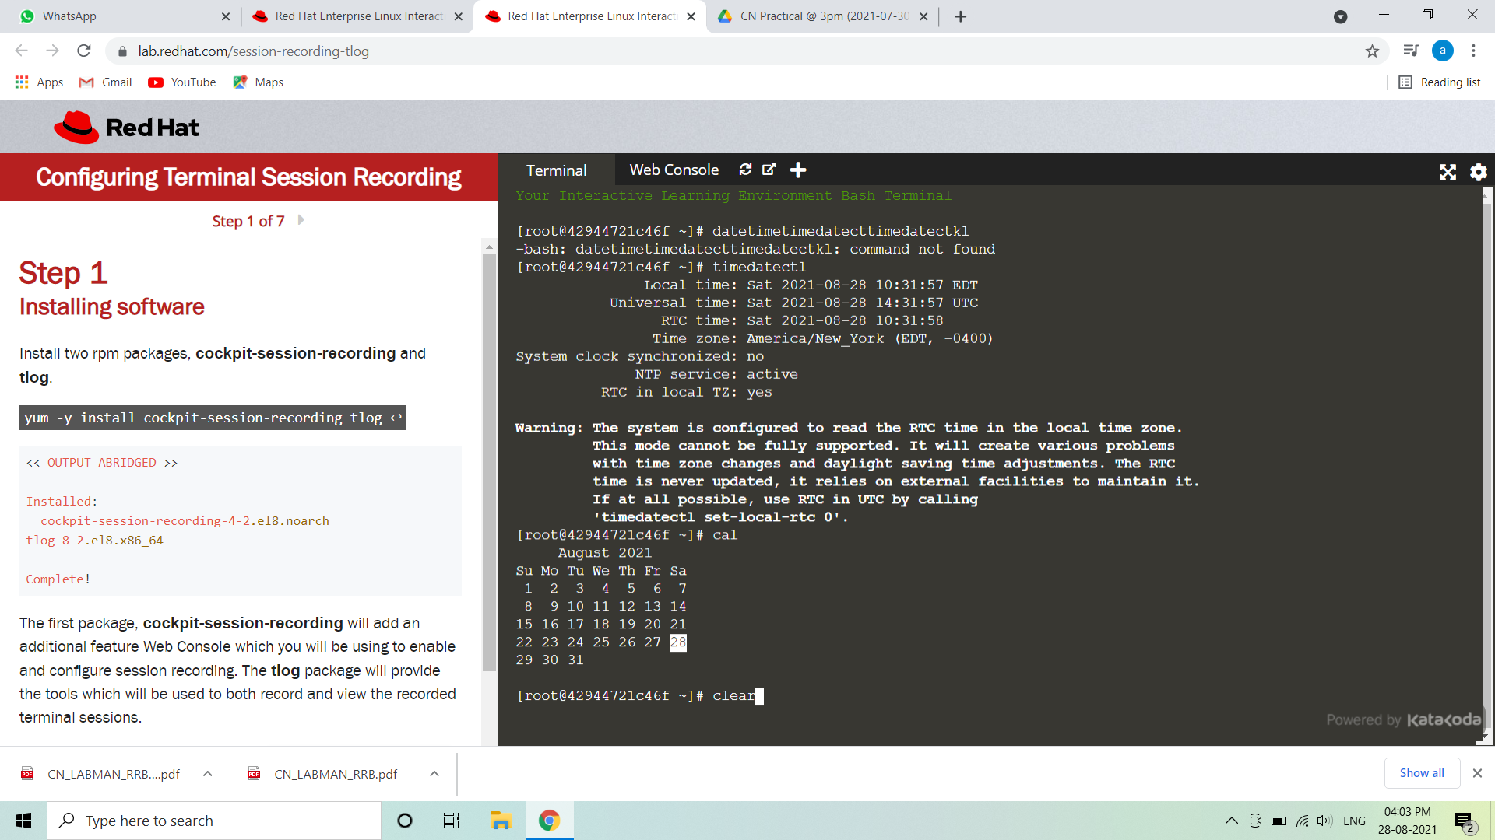

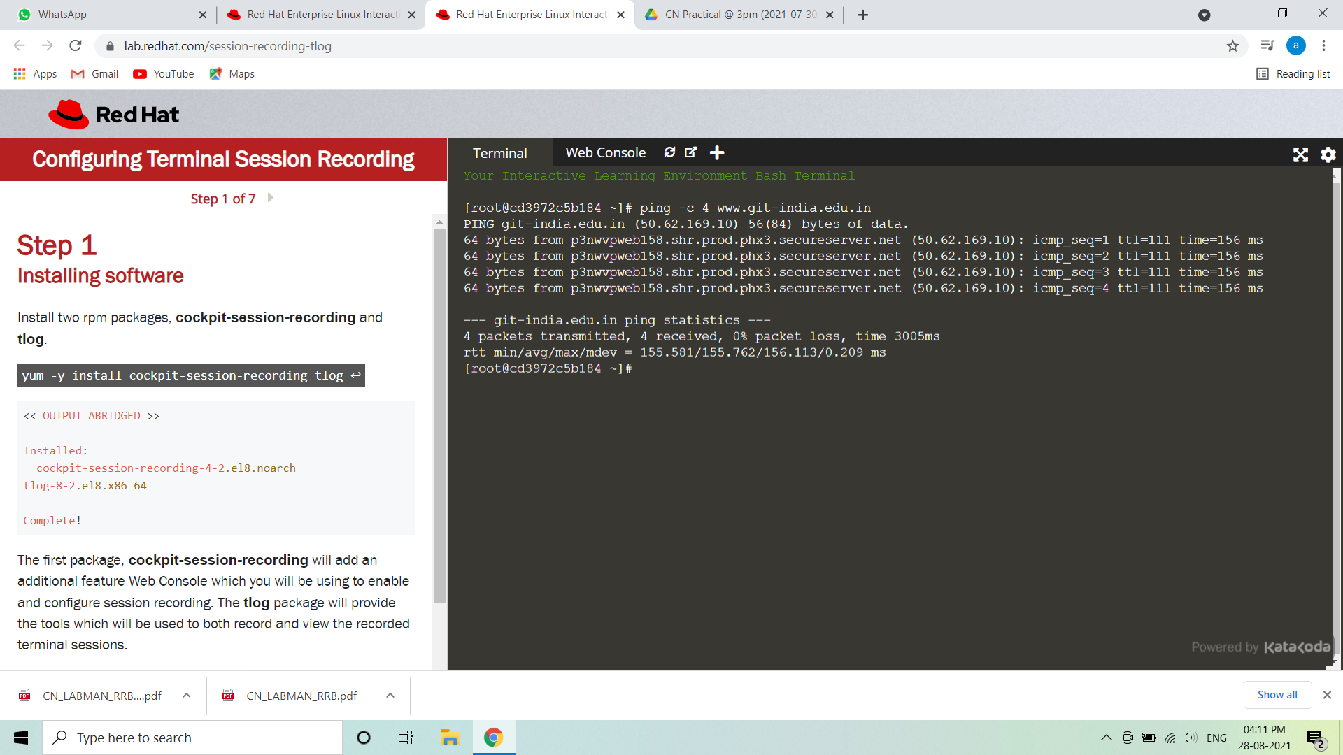

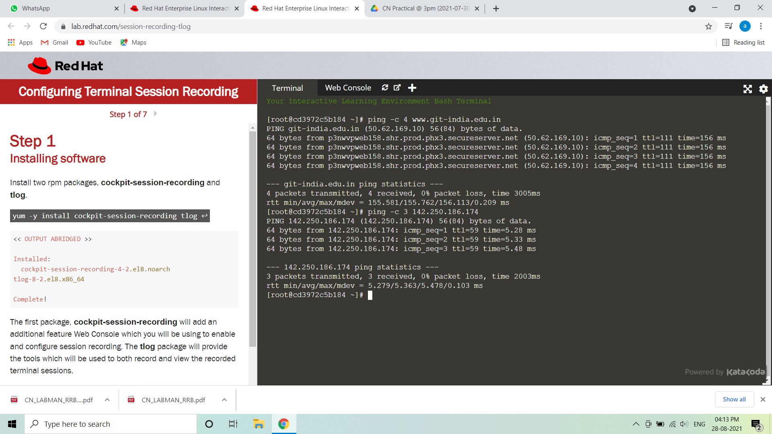





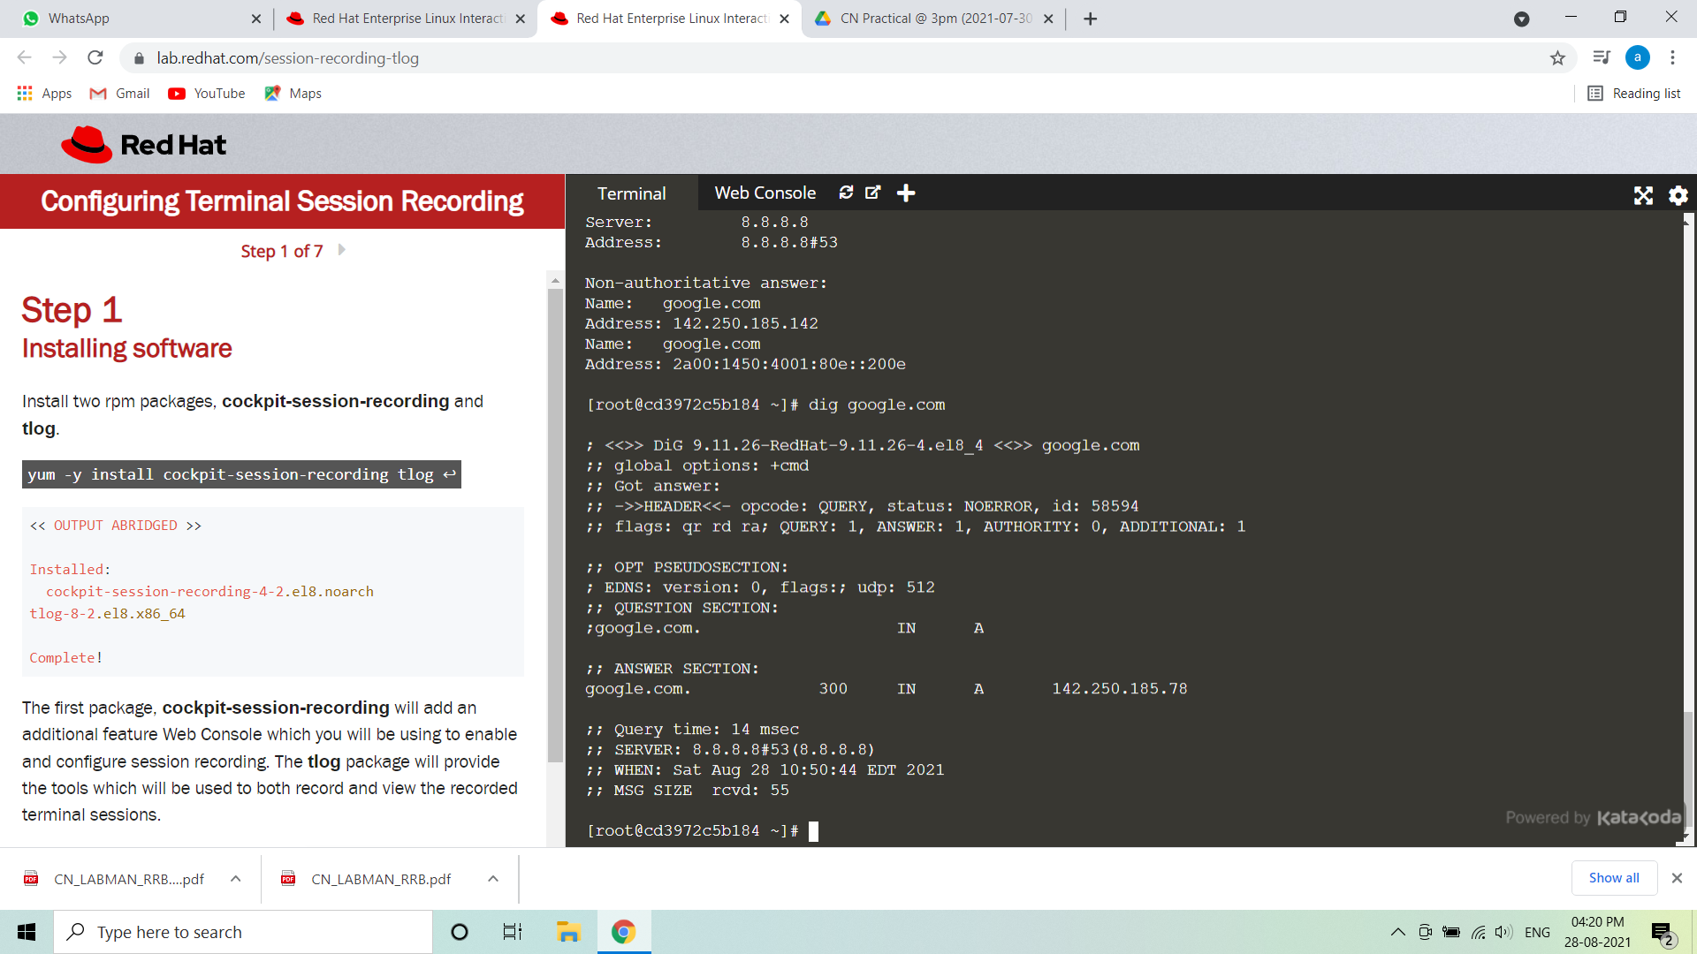

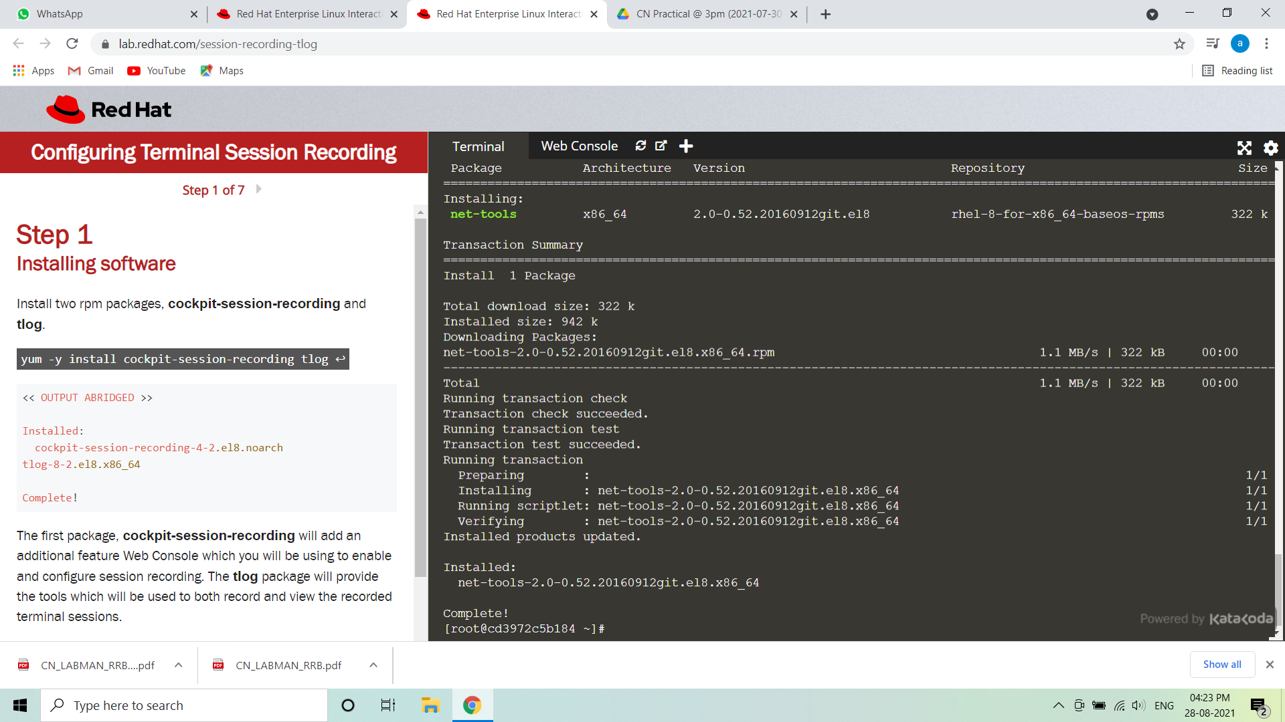

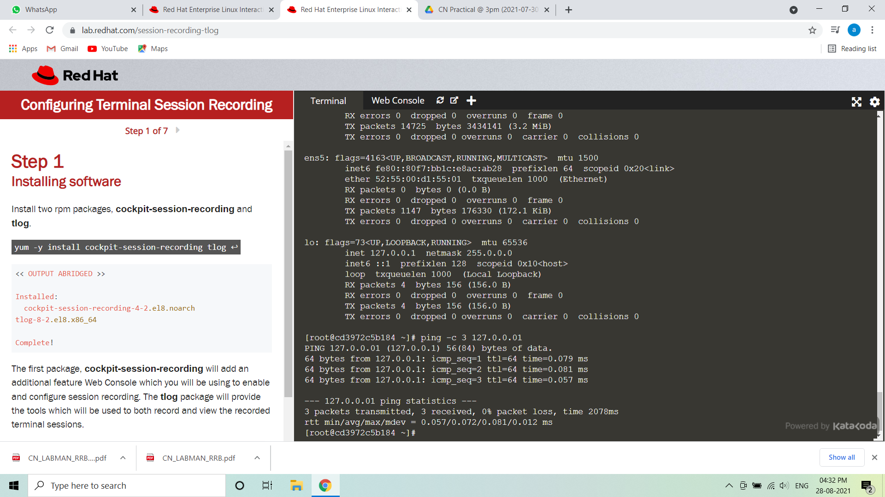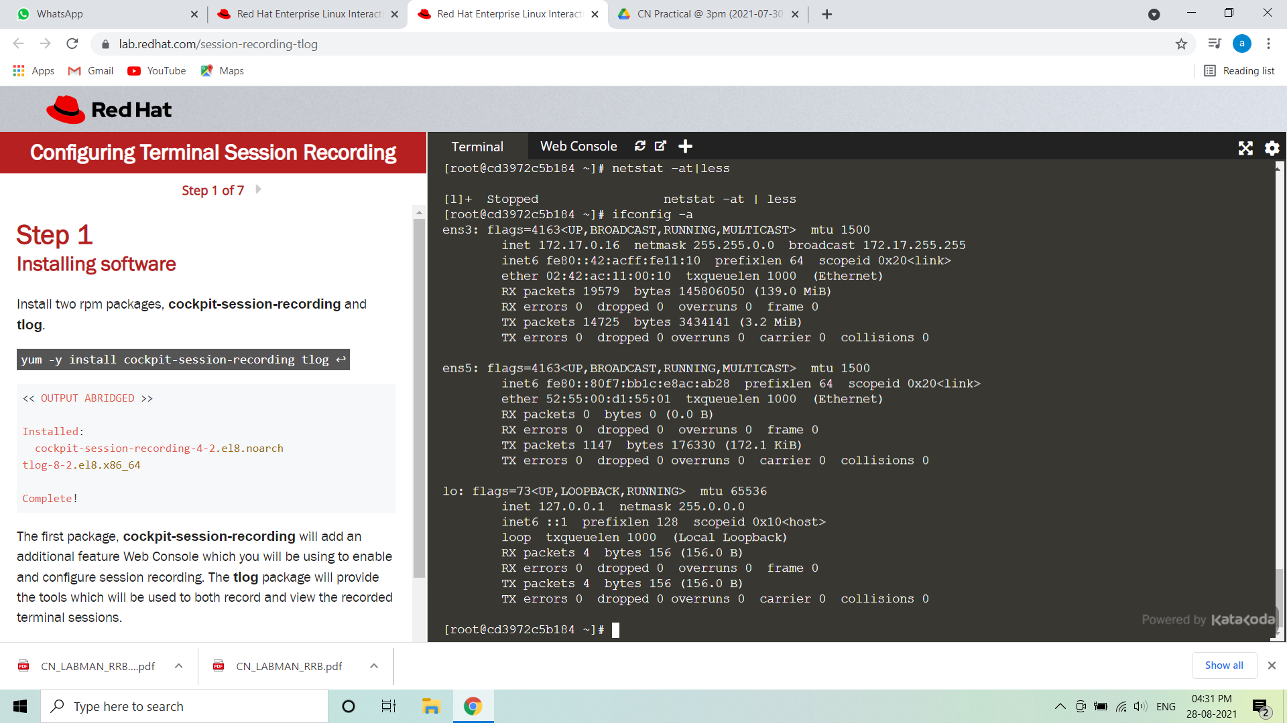

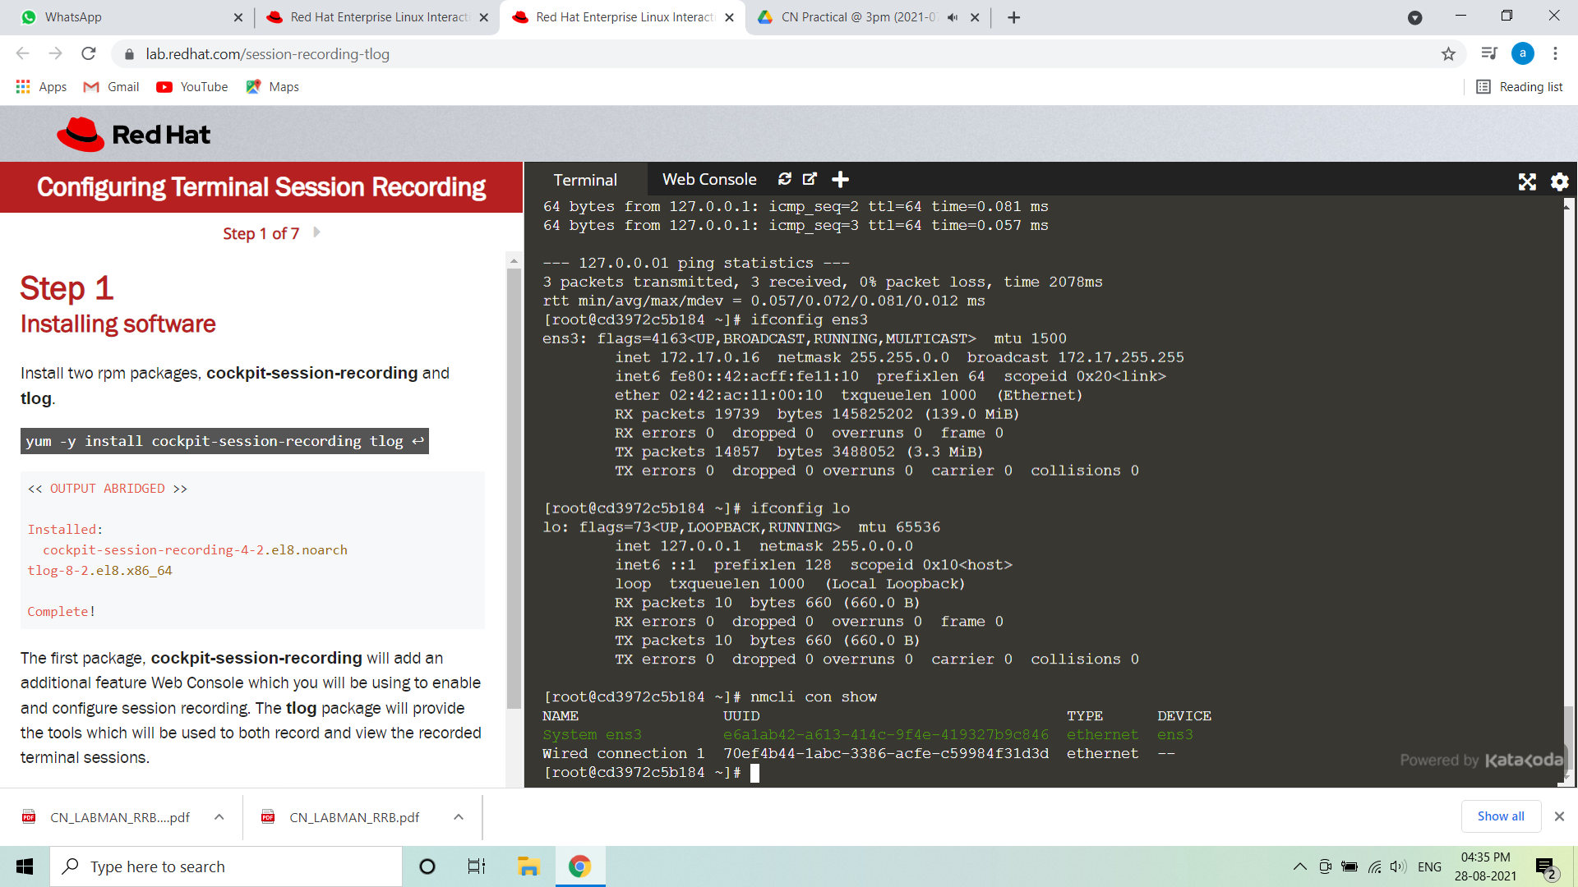

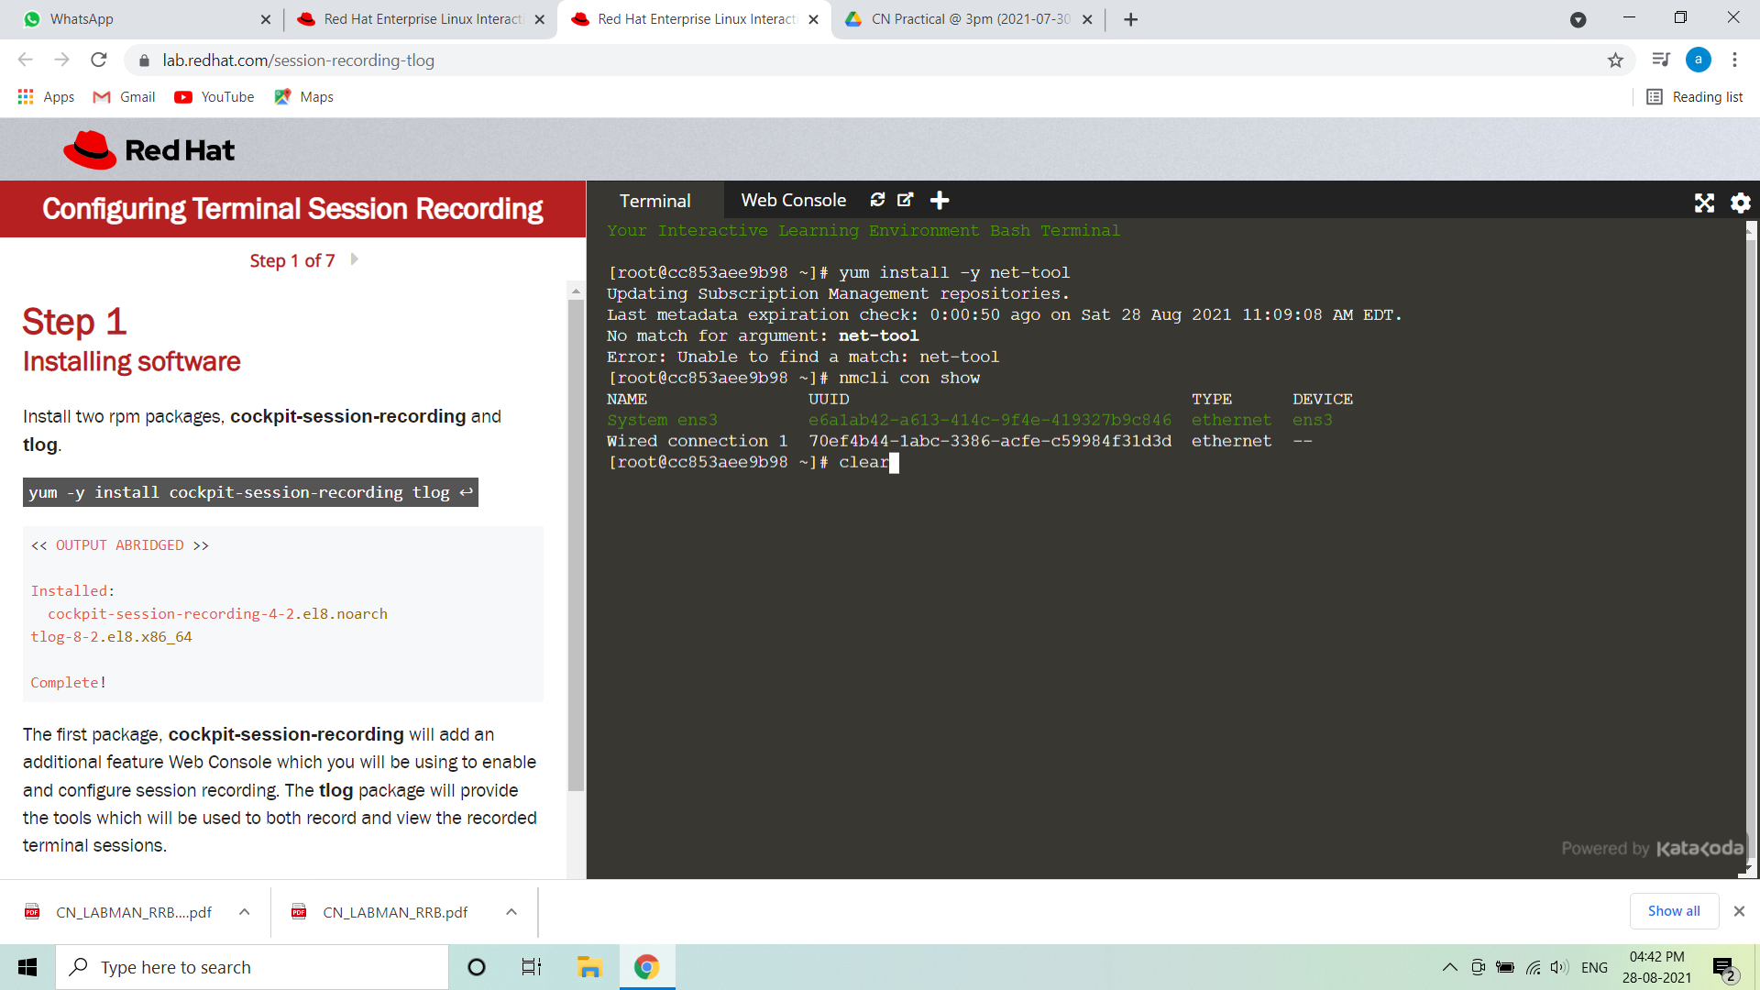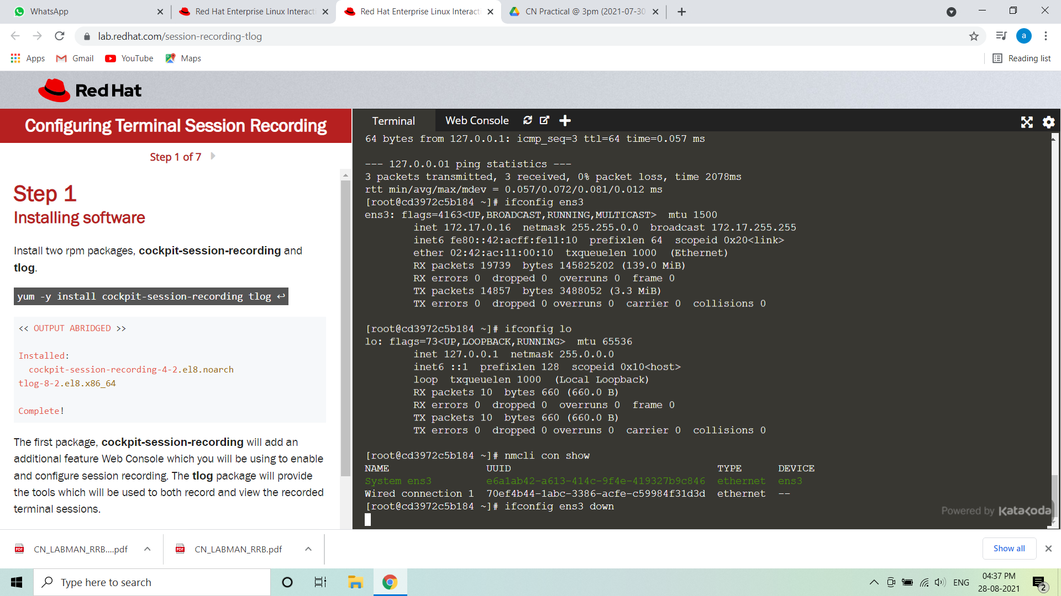

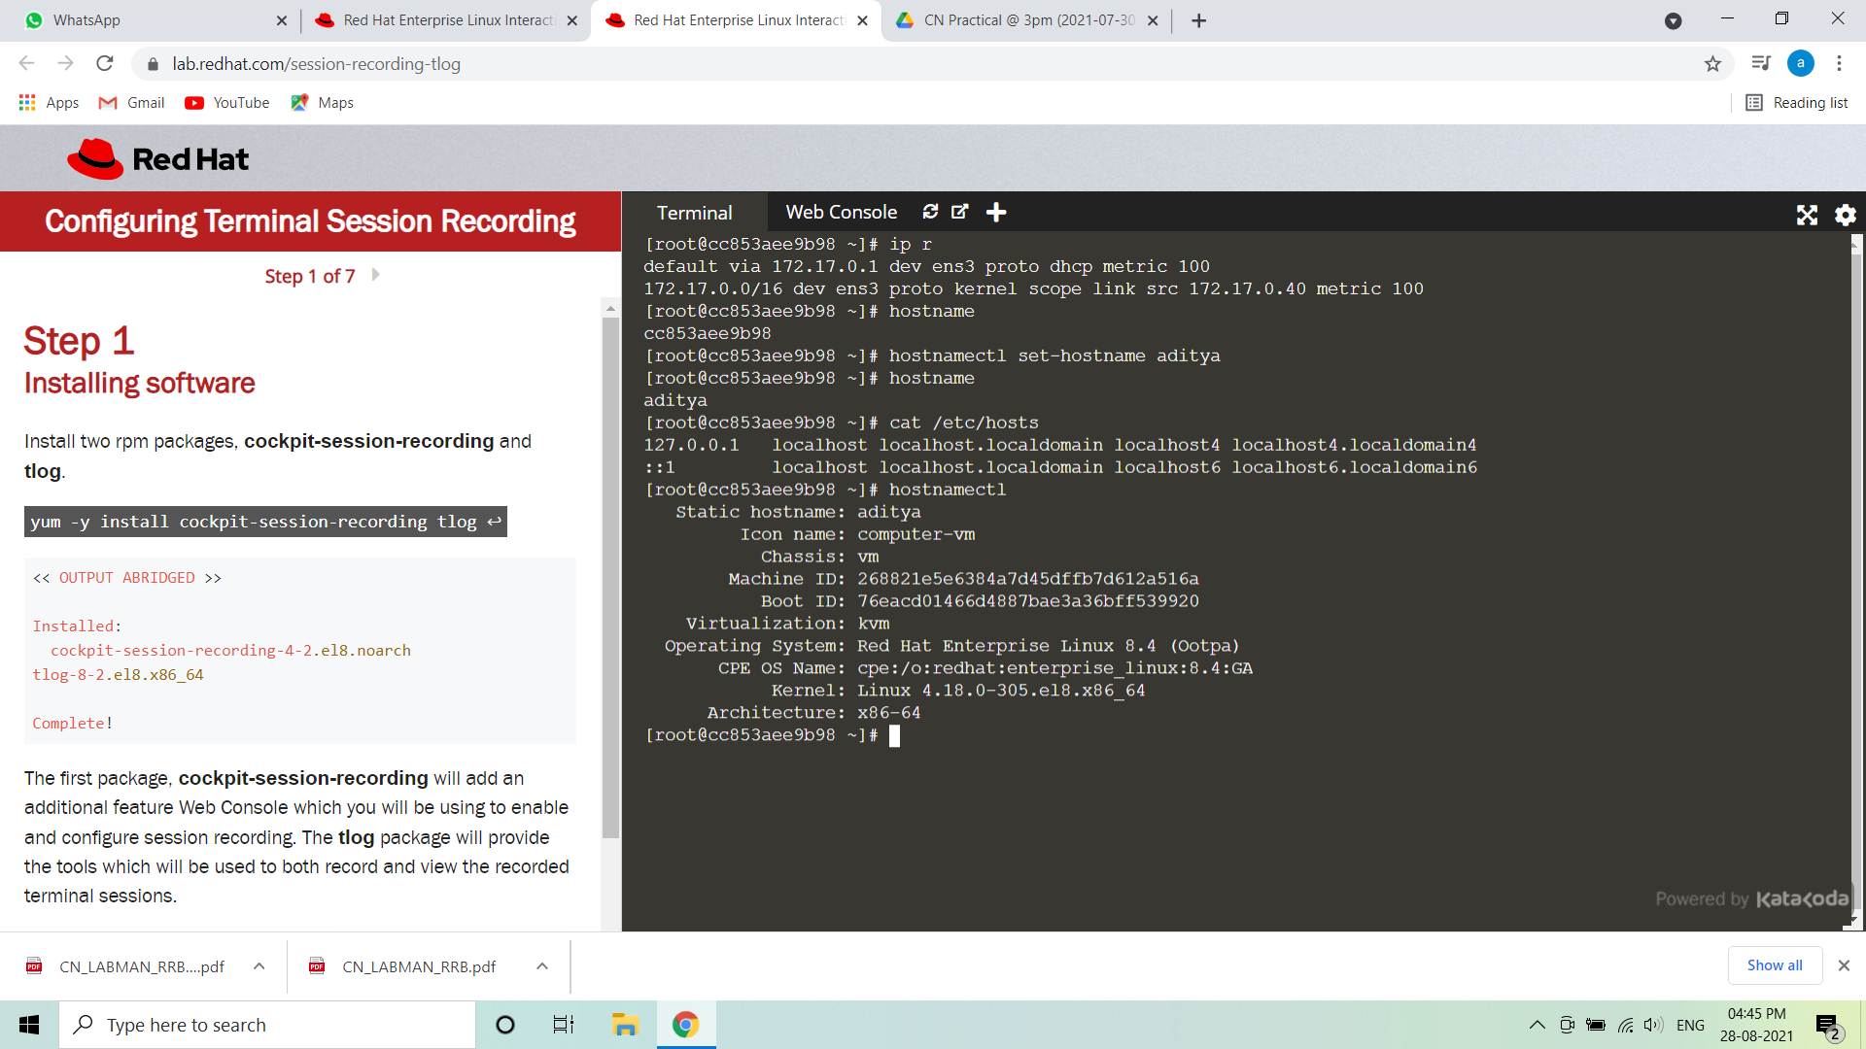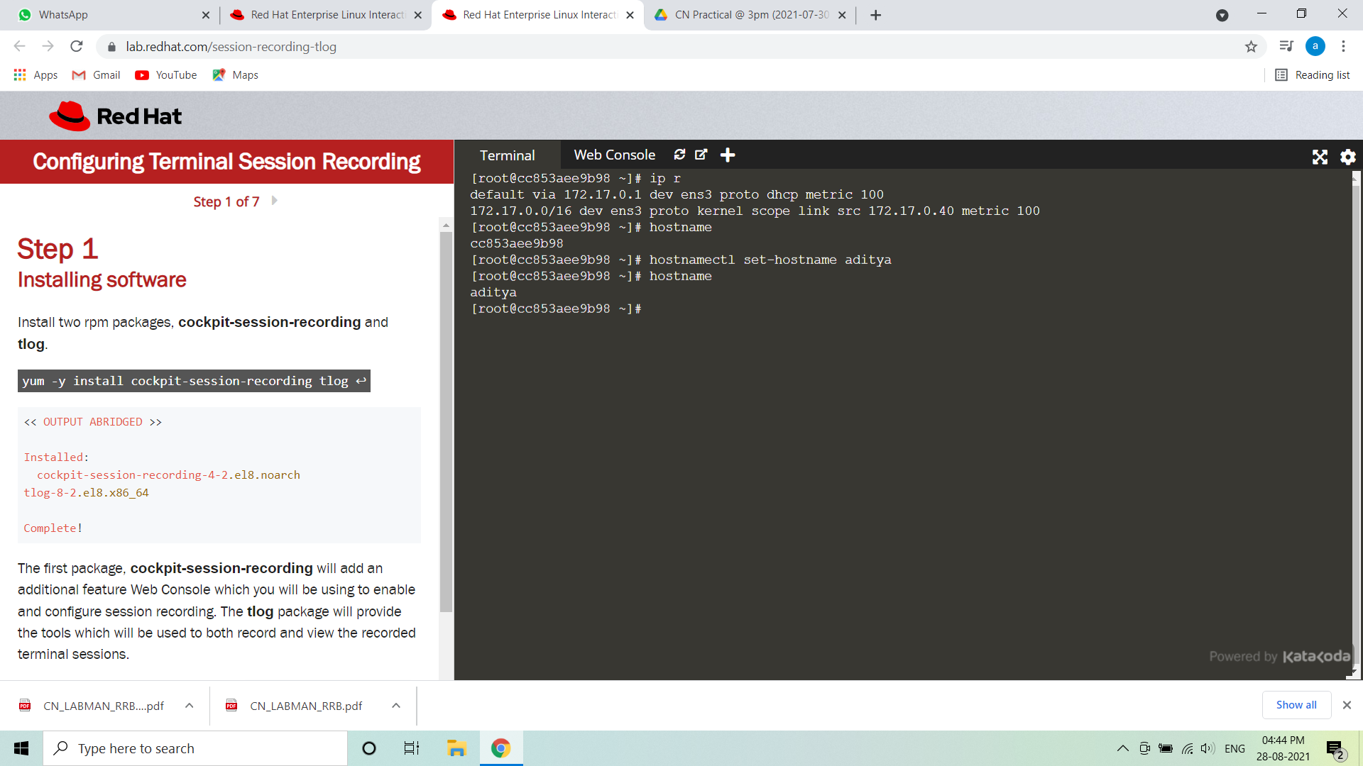

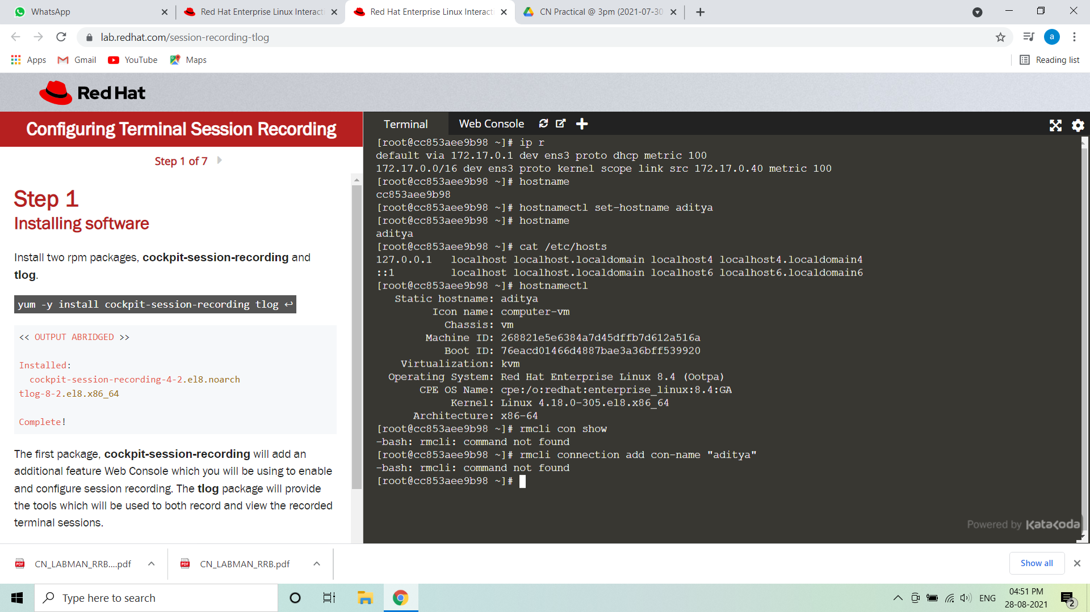

**Conclusion**: Thus the study use of basic networking commands in Linux (ping, traceroute, nslookup, netstat, hostname, ip, ifconfig, dig ) is done using RHEL8 on Virtualbox/Vmware OR Online web virtual environment on Redhat Website.

